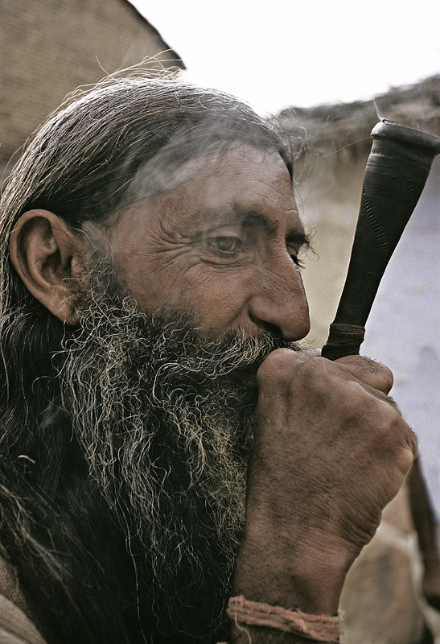

This is one of those photos that really intrigues me when I see it. I have a personal fascination with the weathered, worn out elderly. The depth of the wrinkles in this man's skin almost tells us a story of his life. In this portrait he is smoking some sort of a pipe and appears to be deep in thought, to the point where he doesn't even seem to notice the photographer right next to him taking this picture. The wrinkles in his face exaggerate the feeling of deep thought, and even show years of hardship and stress. The ruggedness of the beard also adds another layer of feeling to this piece, giving him a weathered and beaten appearance. The smoke hazing over the piece softens his right eye so you can't look directly into them, but yet the detail is so great that you can clearly see each gray hair on his head and in his beard, making a very interesting piece to look at.